**Java String Method**

**// Upper and Lower Case**

class Strings {

public static void main(String[] args) {

String greeting = "good morning..! how are you ";

System.out.println("In uppercase : " + greeting.toUpperCase());

System.out.println("In lowercase : " + greeting.toLowerCase());

}

}

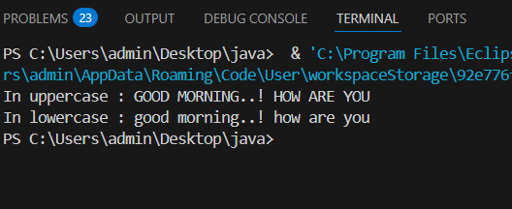

**// Concatenation**

class Strings {

public static void main(String[] args) {

String greeting = "good morning..!";

String que = " how are you ";

System.out.println(greeting.concat(que));

}

}

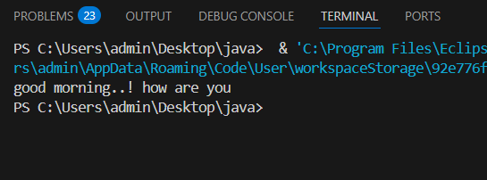

**// Length**

class Strings {

public static void main(String[] args) {

String greeting = "good morning..!";

String que = " how are you ";

System.out.println(greeting.length());

System.out.println(que.length());

}

}

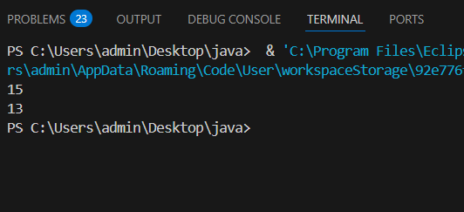

**// Character at Index**

class Strings {

public static void main(String[] args) {

String name = "aman";

System.out.println(name.charAt(2));

}

}

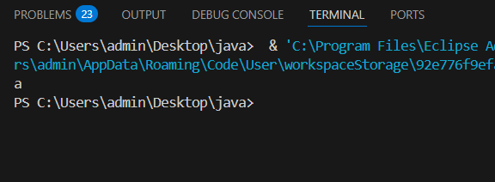

**// Replace Character**

class Strings {

public static void main(String[] args) {

String name = "aman";

String name1 = name.replace('a', 'A');

System.out.println(name1);

}

}

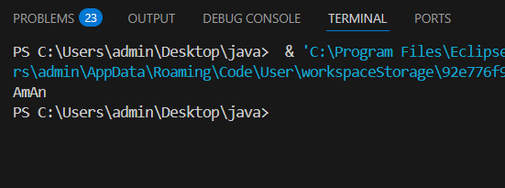

**// Code Point At**

class Strings {

public static void main(String[] args) {

String name = "Aman";

System.out.println(name.codePointAt(0));

}

}

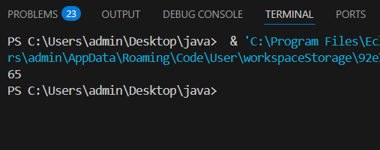

**// Code Point Before**

class Strings {

public static void main(String[] args) {

String name = "Akashy";

System.out.println(name.codePointBefore(3));

}

}

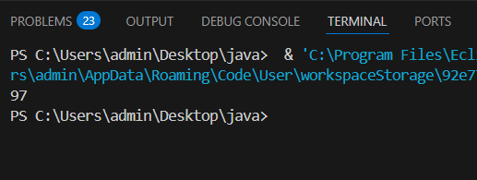

**// Code Point Count**

class Strings {

public static void main(String[] args) {

String name = "hello world";

System.out.println(name.codePointCount(0, 10));

}

}

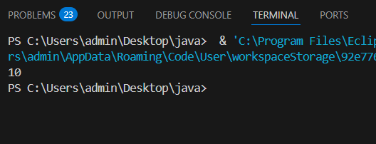

**// CompareTo**

class Strings {

public static void main(String[] args) {

String name = "Aman";

String name1 = "Aman";

System.out.println(name.compareTo(name1));

}

}

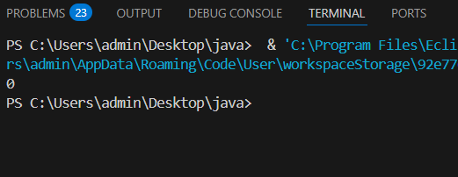

**// CompareTo Ignore Case**

class Strings {

public static void main(String[] args) {

String name = "HELLO";

String name1 = "hello";

System.out.println(name.compareToIgnoreCase(name1));

}

}

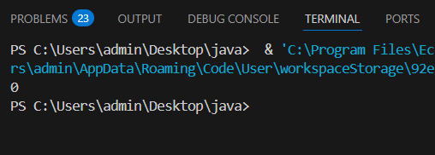

**// Contains**

class Strings {

public static void main(String[] args) {

String greeting = "hii..! how are you";

System.out.println(greeting.contains("how"));

System.out.println(greeting.contains("ii"));

}

}

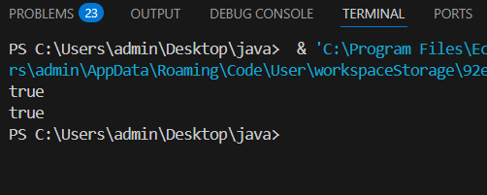

**// Content Equals**

class Strings {

public static void main(String[] args) {

String greeting = "hii..! how are you";

System.out.println(greeting.contentEquals("how"));

System.out.println(greeting.contentEquals("ii"));

}

}

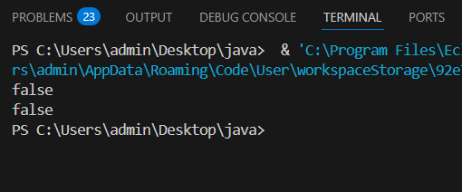

**// Ends With**

class Strings {

public static void main(String[] args) {

String greeting = "hii..! how are you";

System.out.println(greeting.endsWith("how"));

System.out.println(greeting.endsWith("ii"));

System.out.println(greeting.endsWith("ou"));

}

}

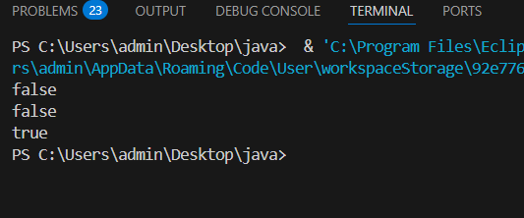

**// endsWith**

class Strings {

public static void main(String[] args) {

String gretting = "hii..! how are you";

System.out.println(gretting.endsWith("how"));

System.out.println(gretting.endsWith("ii"));

System.out.println(gretting.endsWith("ou"));

}

}

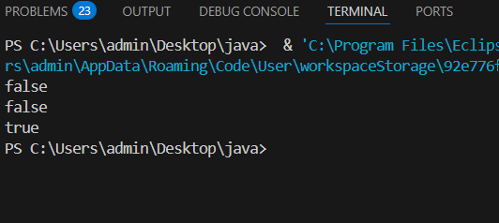

**// equals**

class Strings {

public static void main(String[] args) {

String gretting = "sorry . its not avaliable";

String gretting1 = "sorry . its not avaliable";

String gretting2 = "hii..! how are you";

System.out.println(gretting.equals(gretting1));

System.out.println(gretting.equals(gretting2));

}

}

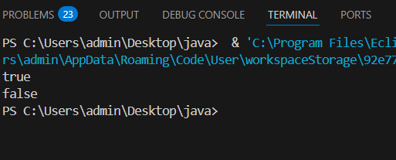

**// format**

class Strings {

public static void main(String[] args) {

String sample = "Hello %s! One dollar is %,d rupee.";

String finalString = String.format(sample, "World", 85);

System.out.println(finalString);

}

}

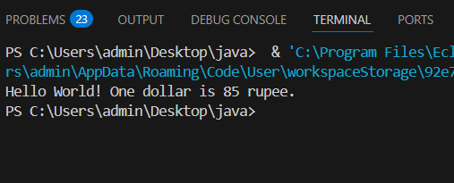

**//getBytes**

public class Strings

{

public static void main(String[] args) {

String name = "Shreya";

byte[] result = name.getBytes();

System.out.println(result[0]);

}

}

